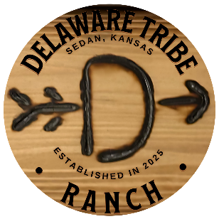

PET POLICY
Pets are not permitted on the property or in the Lodge/Bunkhouse. If a Service Animal will be accompanying someone, please ensure that the Host is notified to avoid wrongful cleaning fees or charges. Service animals may not be left unattended in or at the property.

