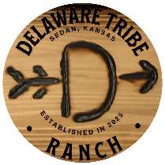

DAMAGES & SECURITY DEPOSIT
- Guests are responsible for damage to the property or its contents.
- Please report any damage immediately.
- A security deposit may be required at booking. If not, you agree to be billed for any necessary repairs or cleaning beyond normal use.

PARKING & PROPERTY ACCESS
- Park only in designated areas.
- Do not block driveways, access paths, or emergency routes.
- Do not enter locked rooms or neighboring properties.

FIRE SAFETY & OUTDOOR USE
- Fires are permitted only in designated fire pits or fireplaces.
- All fires must be attended and fully extinguished after use.
- Obey local fire restrictions or burn bans.
- Do not tamper with smoke detectors or safety equipment.

By staying at this property, you acknowledge and agree to follow all house rules and policies listed above. We appreciate your respect and cooperation—have a wonderful stay!

