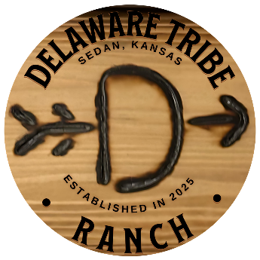

SMOKING & VAPING POLICY
- Smoking and vaping are strictly prohibited indoors.
- Smoking is allowed only in designated outdoor areas.
- Improper disposal of cigarette butts may result in additional fees.
A $600 minimum cleaning fee will apply if smoke odor or residue is detected indoors.

